ICM Assessment 2

All designs

Cameron Jenkins

Mood board:

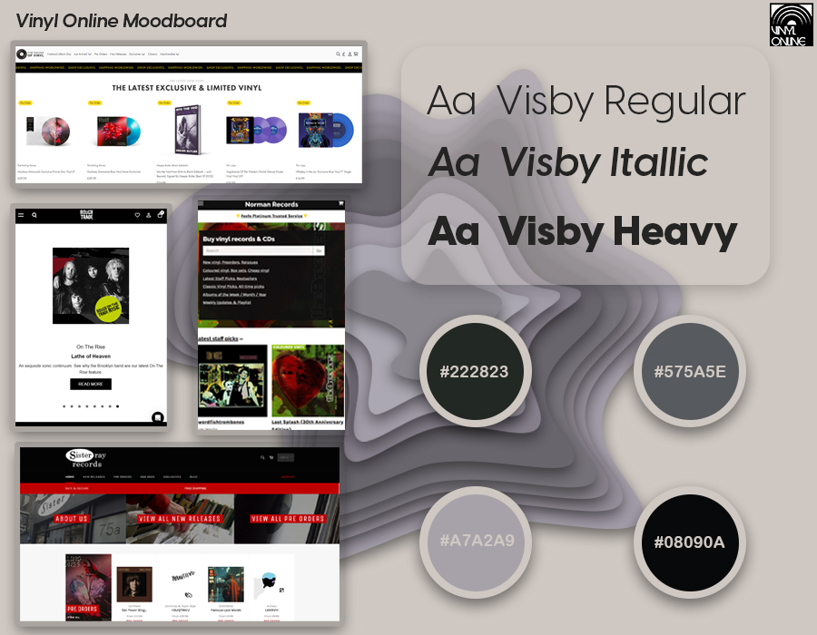 I used the font “Visby” as I liked the simplistic sans-serif look that stands out quite well against most background colours. I generated my colour pallet from the website www.coolors.co as it is a very good tool for finding colours that complement each other while contrasting with background colours to stand out and catch the user’s eye, the muted colours work well at not being too bright and distracting while highlighting key aspects of the page.

Wireframes:

During the process of making the wireframes I took inspiration from sites such as [www.thesoundofvinyl.com](http://www.thesoundofvinyl.com) as this was one of the only modern, minimalistic websites I found for the sale of vinyl’s, I also took inspiration from other e-commerce websites that displayed good use of white space while also keeping text to a minimum to make it as easy to read as possible. In the end I did make changes to the final mock-up as the wireframes were just that, a frame for me to work around and experiment with what looked the best.

Mock-ups:

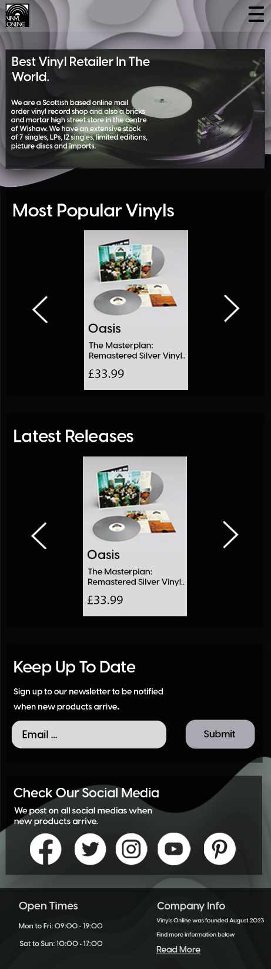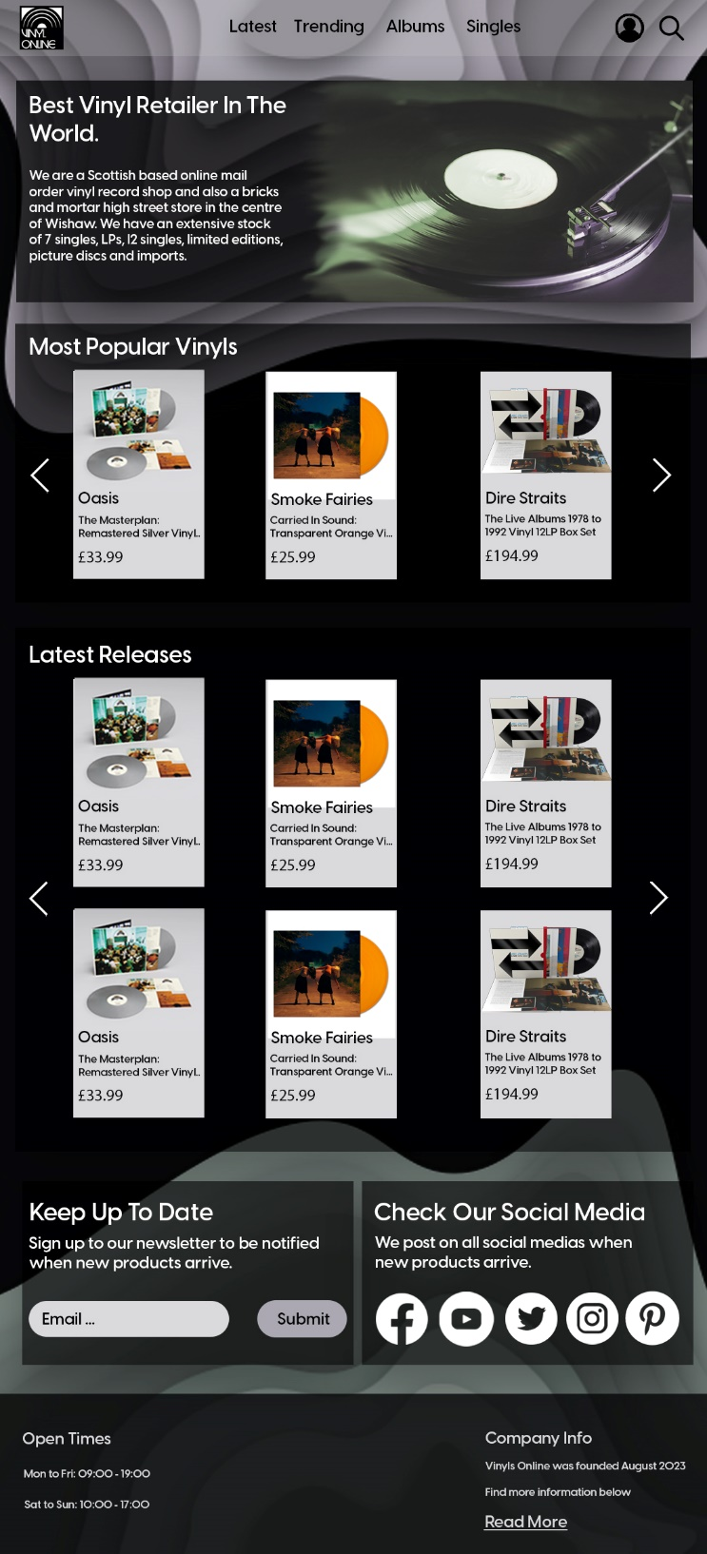I found myself fascinated with different design ideas for backgrounds and I created my own design similar to what Spotify uses with their abstract shapes and colours used to convey different emotions and I took strong inspiration from sound waves to make a 3d design seen at the top and bottom of the webpage which creates a centre of focus that draws the user’s attention to important aspects of the page. Keeping with the theme of simplicity I included image galleries for the vinyl’s to reduce clutter while making the page feel more modern and interactive. Everything in the footer is placeholder text which will be changed with the creation of the website.